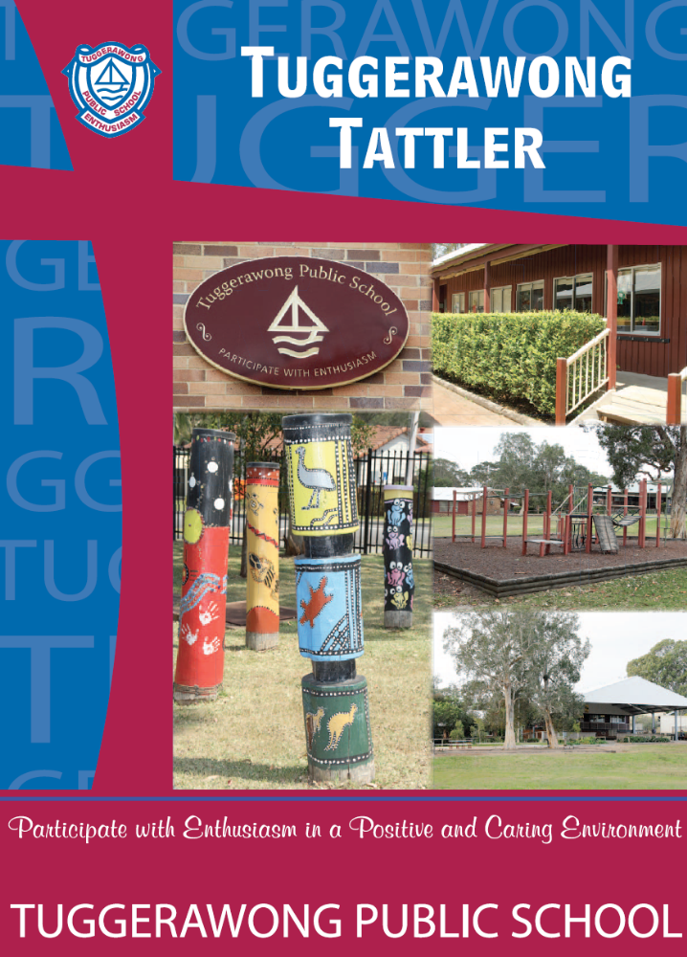

 | ASSEMBLY |  | AWARDS |  | STUDENT OF THE WEEK
KS | Zak Karnowski |  | Ashleigh Penman |  | Jennah Hayden
K/1H | Elijah Lowe |  | Charlotte O'Toole |  | Laylah Akhurst
1S | Benjamin Georgopoulos |  | Eva O'Brien |  | Caitlyn Gallagher
1/2TM | Lily O'Neill |  | Cooper Hall |  | Olivia Caldwell
2G | Darcy Bourke |  | Sinbad Hanney |  | Brock Blackborrow
3/4C | Hayden Jeffreys |  | Amelia Howard |  | Patrick O'Neill
3/4F | Natasha MacNamara |  | Joshua Horsfall |  | Ria Vij
5/6D | Charlotte Caldwell |  | Kaleb Plant |  | Samuel Melinz
5/6M | Jonathan Melinz |  | Julian Foa'i-Auimatagi |  | Darran Hooke

30 November 2015
As we approach the final few weeks of the year, it is a wonderful time to reflect upon what has happened at Tuggerawong Public School throughout 2015.

Last Thursday I had the absolute pleasure of having afternoon tea with all of our Aboriginal families within the school to showcase all of the amazing cultural programs we have been working one

Today we have held our Sports Assembly to celebrate the sporting achievements of our students. Congratulations to all of those students who tried their best on the sporting field throughout 2015.

Tomorrow we will be showing our appreciation to our parents, friends and community members who have helped us at Tuggerawong Public School this year with a Thank You Morning Tea. On behalf of our teachers and students, I would like to thank everyone who has provided us with assistance this year. If you have not yet received an invite to this morning tea but have helped out at the school this, please feel welcome to attend.

Next week we will be holding our end of year Presentation Day. I look forward to seeing everyone then.

David Ireland - Principal

AROUND THE CLASSROOMS

STAGE 2
The next couple of weeks of the term are going to be busy. It is hard to believe that this year is nearly over! Stage 2 homework will cease this week, however please encourage your child to continue reading throughout the holidays.
3/4C and 3/4F have been practising their class carol for the Christmas Carols night on Wednesday 9th December. We hope to see you all there.

Primary class party notes were sent home last week so a reminder to send in your child’s note and money before Monday, 7 December. Students must have their silver licence to attend. Students who are not attending the excursion are expected to still to come to school as supervision will be provided.

Stage 2 will be holding auditions for the Talent Quest this Wednesday after lunch. Please let your classroom teacher know if you would like to audition.

Thank you to those parents who have returned their Helpers Morning Tea RSVP! If you have not done so could you please send it in with your child ASAP for catering purposes. Thank you to all our wonderful helpers we appreciate everything you do for the kids!

We are also collecting gifts for The Salvation Army Christmas Appeal. Gifts should not be wrapped and there will be a box in our classrooms for you to deposit your gifts and donations to this fantastic cause. If you wish to participate your gifts will need to be in by Wednesday, 9 December.

This Friday, 4 December will be our Aussie of the Term Assembly and our last assembly so please make sure your child brings in their home reading diary and licence in early in the week to ensure they receive their award or licence before the end of the term.

Please do not hesitate to make a time to come and speak with us if you have any questions or queries as we have a busy few weeks coming up!
Have a great week,
Miss Anderson and Mrs Farnworth

5/6D
WOO HOO! Week 9! This term is flying by! We have been very busy and there are no signs of the pace slowing down. We are truly on the countdown to the Christmas Holidays!

Wadalba Community School Orientation Day – Yr 7 students 2016.
Orientation Day is on this Wednesday, 2 December, 2015. Parents are to arrange their own transport for students to get to and from WCS. Parents will be asked to drop off their child by 9.00am and arrive for parent information session at approximately 2.15pm with the day finishing at 3pm. The uniform shop will be open on the day.

Preparations for our Year 6 Farewell are well underway. Please remember to have all Year 6 Farewell RSVP’s returned to Mrs Day by Monday, 7 December, 2015.

Please also return permission notes and money for Class party excursion (to the movies) as soon as possible.

If you have any questions or concerns, please do not hesitate to contact me.

Have a fantastic week!

Kate Day
Assistant Principal

DATES FOR YOUR CALENDAR

Tuesday, 1 December - Helpers Morning Tea – 11.00am


Tuesday, 8 December - Scooterthon
Wednesday, 9 December - Carols Night
Friday, 11 December - Presentation Day
Monday, 14 December - Class Reward Day
Tuesday. 15 December - Year 6 Farewell
Wednesday, 16 December - Talent Quest

Wednesday, 16 December - Last day for Students
Thursday, 17 December - STAFF DEVELOPMENT DAY
Friday, 18 December - STAFF DEVELOPMENT DAY

2016
Wednesday, 27 January - STAFF DEVELOPMENT DAY (No Students)
THURSDAY, 28 JANUARY - Students return (Yr 1 – Yr 6)


PARENT HELPERS MORNING TEA

All of the parents who have helped support the school during 2015 are invited to our Parent Helpers Morning Tea.
Place: Library
Date: Tuesday, 1 December 2015 (tomorrow)
Time: 11.00 am
We look forward to seeing you there!

TUGGERAWONG SCOOTERTHON

This term as an end of year activity, students will have the opportunity to participate in Tuggerawong’s first ever SCOOTERTHON!
It will be held on Week 10, Tuesday, 8 December.

Each student will be given a fundraising sheet to collect donations for their ‘scooting’. A minimum of $5 needs to be raised for any student to participate. All funds will go to enhancing student learning during their everyday at school.

There will be prizes from ‘Flipout’, ‘Steve Forrest Music’, ‘McDonalds’ and ‘Wyong Leagues Club’ for those who raise the most funds. A separate note will come home with more information.
Thank you - Naomi Coafield (Co-ordinator)

TUGGERAWONG PUBLIC SCHOOL

PRESENTATION DAY

Friday, 11 December 2015

9:30am

School HALL

Everyone Welcome

Participate with enthusiasm
In a positive and caring environment



Family Carols Night

Wednesday, 9 December
Family Picnic, Dinner and BBQ available from 5.00pm

Coffee
Van
“All About Taste”
Serving Wraps,
Nuggets and chips
drinks
BBQ
Sausage sandwiches

Fairy Floss
Face Painting
Santa Photos
Old Fire Truck Theme

Community singing and Choir performance at 6.00pm
Class performances from 6.30pm
Bring your picnic rugs and fold up chairs and
join us at the Library COLA and grassy areas nearby.
Picnic rugs only at the front near the stage please.
The evening concludes with the
Christmas Hamper Raffle
so get your tickets

Important reminder
For safety reasons children should not be on the fixed equipment, in the sandpit or cubby, as everyone will be enjoying the carols and unable to provide the direct supervision they need. Teachers will be busy with their classes.

Have a great night
TALENT SHOW


Auditions will continue this week and until mid-next week. Children need to let their teacher know in advance that they would like to audition so that a suitable time can be arranged. If their group has students from a few classes they can either ask any of their teachers or check with me and I will audition them. Children need to come prepared with suitable music to their auditions.

A reminder that the Talent Quest will be held on the last day students attends Wednesday, 16 December from 9am.
Mrs Hurley

P & C FUNDRAISING

CHRISTMAS CAROLS – TUESDAY , 9 DECEMBER 2014

We are hosting a Family Picnic, so bring your blankets and chairs and Nanas, Pop, Aunts and Uncles, cousins and friends to share in a wonderful night.

Thanks for all your donations for our Christmassy hamper treats, there will be many hampers to win on the night so start selling those tickets!!

To help you get into the Christmas spirit there will be:

Christmas decoration face painting on cheeks - $2
Fairy Floss stall - $3.00
Silly Santa Photos - $7 each or $5 each for two or more, so make a crazy hat or silly glasses or find a weird wig to wear, the Silliest photo wins a prize!!
CATERING/FOOD
P & C BARBEQUE
Sausage Sandwich $2.50
Soft drinks/Water $2.00


‘All About Taste’ - CHRISTMAS CAROLS MENU
Menu in next week’s newsletter

CHRISTMAS HAMPER DONATIONS
Donations can still be made for our Christmas Hampers. If you would like to make a donation there is a basket in the front office.
Any donations would be appreciated eg food items (as long as they are in date and non-perishable), Christmas items, soft drinks, chocolates, bon bons, nuts, biscuits, chips, puddings etc. These Hampers will be drawn on Christmas Carol Night

RAFFLE TICKETS – Christmas Hampers

Raffle tickets will be sent home with today’s newsletter. If you need more tickets they will be available from front office.

******* UNIFORM SHOP *******
The last day for the Uniform Shop this year will be next Wednesday, 9 December 2015.

2016 Uniform Shop hours - Wednesdays from 8.45am – 9.15am in Front Office building – window carpark side.

2016 -The Uniform Shop will be open on Wednesday, 27 January 2016 (Staff Development Day,) between the hours of 9.00 - 11.00am for sales.

*** Long/short sleeve- Maroon school shirts - $10.00 each

2015 - TERM 4 - CANTEEN ROSTER
Monday  30/11/15 | Tuesday  1/12/15 | Wednesday  2/12/15 | Thursday  3/12/15 | Friday  4/12/15
Marg Simpson  Fred Simpson | Marg Simpson  Fred Simpson | Lindal Penman | Amy Baars | Kristy Reeson
Monday  7/12/15 | Tuesday  8/12/15 | Wednesday  9/12/15 | Thursday  10/12/15 | Friday  11/12/15
Marg Simpson  Fred Simpson | Marg Simpson  Fred Simpson | Lindal Penman | Laura Rosales | Rebecca A
Monday  14/12/15 | Tuesday  15/12/15 | Wednesday  16/12/15 | Thursday  17/12/15 | Friday  18/12/15
CLOSED  CLASS PARTIES | CLOSED  Stocktake  /cleaning | CLOSED  LAST DAY TERM 4
FLEXI SCHOOLS – is up and running. Please use this way of ordering if possible. The Canteen has a laptop available for parents to order if needed.
Please register now.
PLEASE NOTE
2016 – the canteen will not be accepting manual orders.

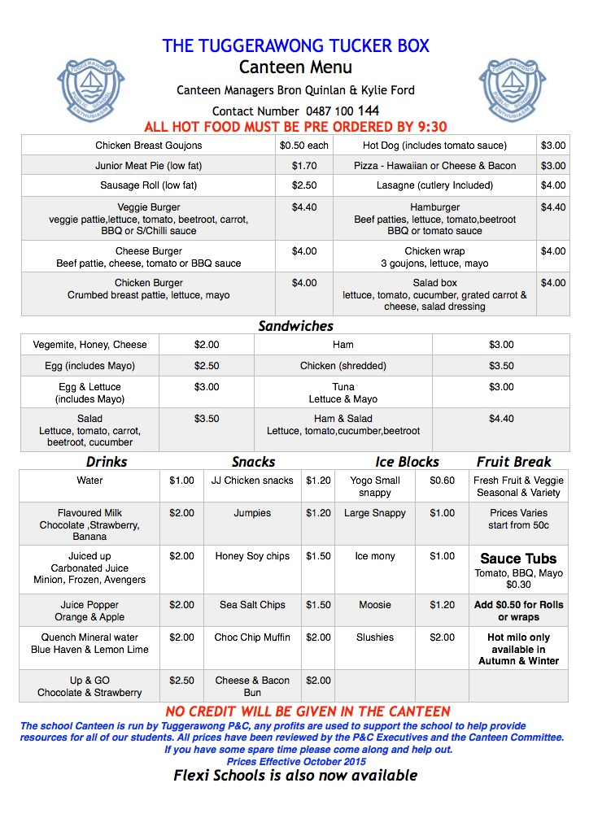
TUGGERAWONG PUBLIC SCHOOL
FAMILY CONTACT DETAILS UPDATE FORM

STUDENTS NAME/S: ………………………………………………………………………………………..
..…………………………………………...............................................
FAMILY CONTACT DETAILS
RMB/PO Box:……………….. Street No/Property Name: ……………………………
Street Name: …………………………………………………………………………………………………………………….
Suburb/Town: ………………………………………………………. Post Code: ……………………………….
Home Telephone Number: ……………………………………..
Mother/Guardian Name: ………………………………………………………………………………………………..
Mobile Number: ………………………………………….. Work Number: ...................................
Father/Guardian Name: ………………………………………………………………………………………………….
Mobile Number: …………………………………………. Work Number: ....................................
EMERGENCY CONTACT DETAILS
Name - Relationship to Family | Daytime Phone | Mobile

CONTACT DETAILS FOR PARENT NOT RESIDING WITH STUDENT
Parent/Guardian Name: ……………………………………………………………….
Relationship to Student: ……………………………………………............................
Home Address: …………………………………………………………………………………………………..
Home Telephone Number: ………………………………………. Mobile Number: ……………………………….

STUDENTS NAME/S: ……………………………………………………………………………………
..…………………………………………............................................
……………………………………………………………………………………..

SCHOOL HOURS:
School starts 9.00 am (supervision is available at 8.45 am)
Lunch 11.00 am to 11.55 am (children eat in a supervised area for
10 minutes)
Recess: 1.55 pm to 2.15 pm
School Finishes: 3.00 pm
On occasions children may need to be brought to school before 8.45am. Between 8.30am and 8.45am there is minimal supervision available. Students should not be at school before 8.30am as there is no supervision available.

TERM DATES 2015
Term 1 Wednesday, 28 January – Thursday, 2 April
Term 2 Tuesday, 21 April – Friday, 26 June
Term 3 Tuesday, 14 July – Friday, 18 September
Term 4 Tuesday, 6 October - Wednesday, 16 December

Staff Development Days: 27 January
20 April
13 July
17/18 December

TUGGERAWONG PUBLIC SCHOOL STUDENT ABSENCE NOTE

My child ………………………………………………………………………………………. of class ………………………

Was absent from school on ………………………………………………………………… for the following reason:

…………………………………………………………………………………………………………………………………………………

…………………………………………………………………………………………………………………………………………………

Parent Name: ………………………………………………………………….. Date: …………………………………..

Signature: …………………………………………………………………………….



